FINAL EXCEL EDA FOR NETFLIX:

Insights drawn:
- Movies dominate over TV Shows.
- Dominating ratings are:
i) TV-MA
ii) TV-14
iii) TV-PG.
- Most of the content was produced in December.
- Dominating Genres are:
i) Dramas
ii) Comedies
iii) Action & Adventure.
- Top 4 Directors are:
i) Jay Chapman
ii) Jay Karas
iii) Marcus Raboy
iv) Raúl Campos
- Most of the contents were produced in the period of 2015- 2020.
- Most of the content was contributed by the United States.

Visualizations drawn:
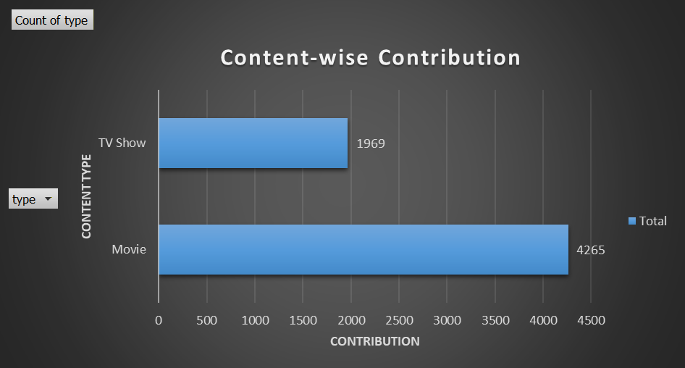
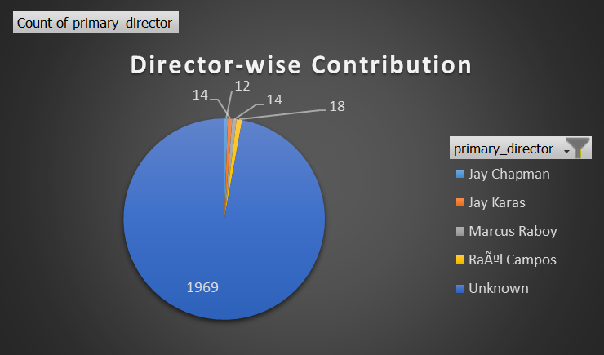
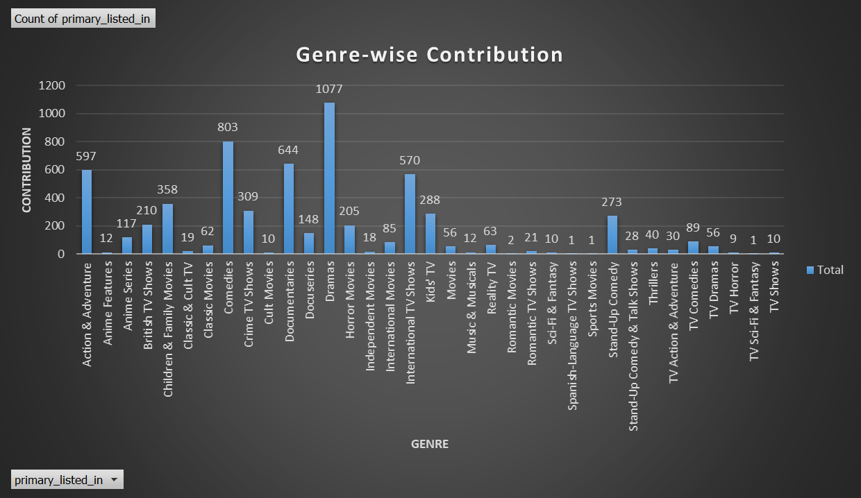
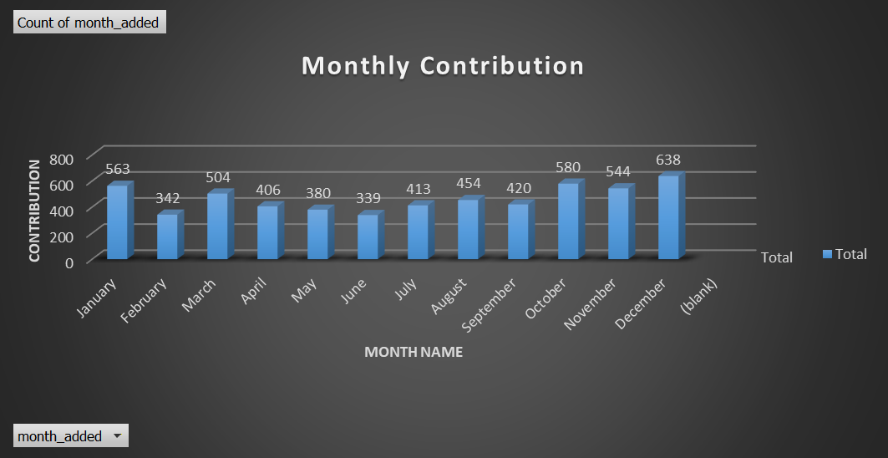
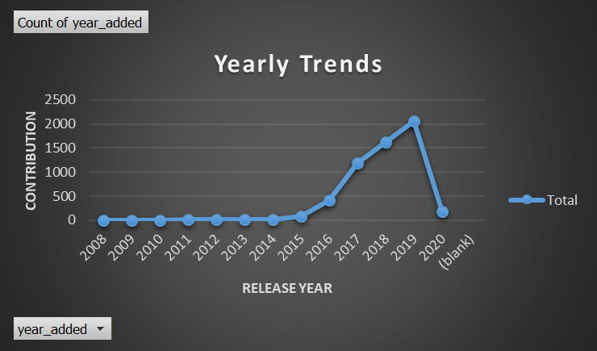
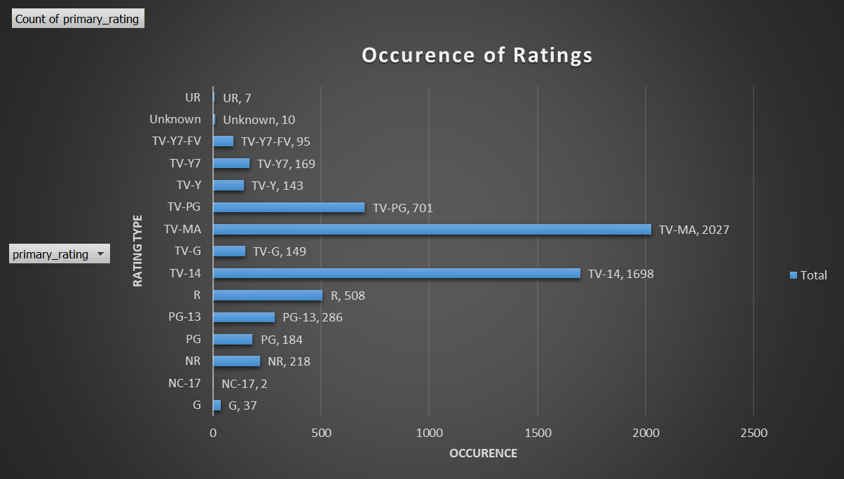

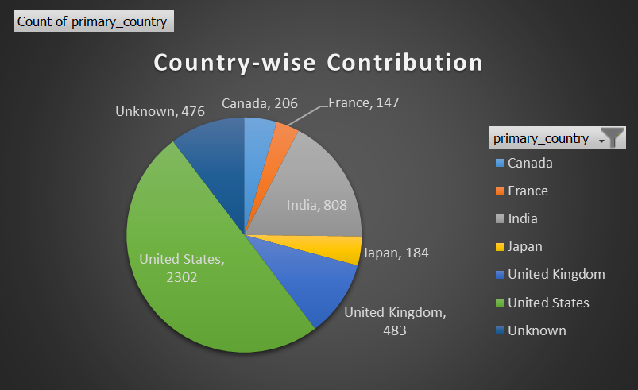

Slicers:
